Classes and Objects 3

Continue from the Fraction class

1. If p and q are both variables of type Fraction, under what circumstances will the expression p == q have the value true?

p and q

As p and q are both defined as Fractions, the variables itself only hold the **memory address**  of the objects. Actually printing the values would return a bunch of characters as a string, which since they are not the same object, therefore do not have the same address. Resultantly so, this value would be false. The only way it would be true is if we explicitly set p to be equal to q (Or vice versa: Fraction p = q;)

1. Suppose that p and q are both of type Fraction with p representing 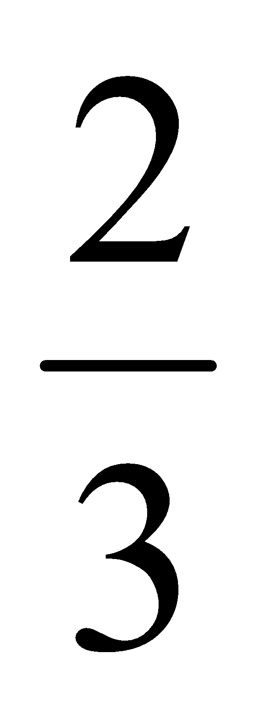 and q representing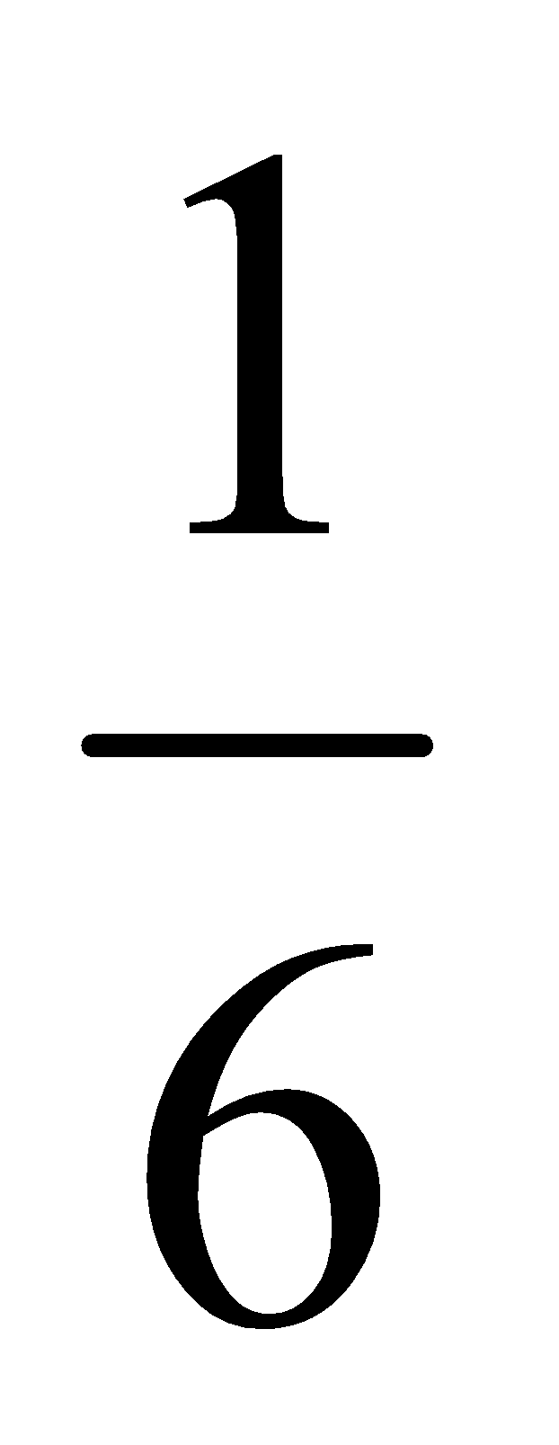.
   1. Draw a diagram like those shown in class to illustrate this situation.

| Object p: Memory Address = Mp | Object q: Memory Address = Mq |
| --- | --- |
| p.numerator = 2 | q.numerator = 1 |
| p.denominator = 3 | q.denominator = 6 |

* 1. If the statement p = q; is executed, draw a diagram to illustrate the result.

| Object p: Memory Address = Mq | Object q: Memory Address = Mq |
| --- | --- |
| p.numerator = q.numerator = 1 | q.numerator = 1 |
| p.denominator = q.denominator = 6 | q.denominator = 6 |

1. Write a definition of an equals method for the Fraction class. Your method should return true if and only if the Fraction objects being compared represent *equivalent* fractions.

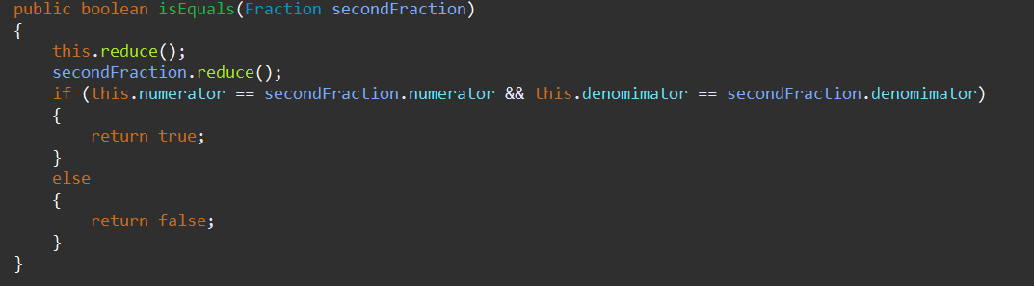

1. Write the toString method for the Fraction class which allows an Fraction object to be outputted in the form <num>/<den>, e.g., 2/3

